ADOPTED BY
RESOLUTION No.1
of the Sole Member
as of August 17, 2018

CHARTER
The Fund for Support and Development of Theosophy

city of Saint-Petersburg
2018

1. GENERAL TERMS AND PROVISIONS

1.1. The Fund for Support and Development of Theosophy , hereinafter referred to as ''the Fund'', is a unitary non-commercial organization without any membership requirements, incorporated based on voluntary proprietary contributions aimed at reaching of the goals as specified hereinunder.
1.2. Full name of the Fund in the Russian language:
Фонд поддержки и развития ТЕОСОФИИ.
1.3. Short name of the Fund in the Russian language:
Фонд ТЕОСОФИИ.
1.4. Full name of the Fund in English:
The Fund for Support and Development of Theosophy
1.5. Short name of the Fund in English:
The Theosophy Fund
1.6. THEOSOPHY is knowledge about Cosmos, nature and the human being.
1.7. Place of location of the Fund: Saint-Petersburg, the Russian Federation.
1.8. The Fund is considered to be a legal person as of the date of registration in the Unified State Register of Legal Entities. The Fund has been incorporated for an indefinite period.
1.9. The Fund has independent assets and is answerable for its obligations with all the said property; the Fund on its own behalf purchase and perform any civil rights, bear civil responsibilities, act as a plaintiff or a defendant in a court of law.
1.10. The Fund acts as an independent accounting entity able to properly open up any bank account in the territory of the Russian Federation and abroad.
1.11. The Fund has a seal specifying the complete name in the Russian language. The Fund may use stamps and letterheads specifying its name.
1.12. The Fund may have own symbols, viz.: emblems, coat of arms, other blazonry, flags, and hymns, description of which should be specified hereinunder.
1.13. The Fund has an emblem.
1.13.1. Image of the emblem.
Option 1.

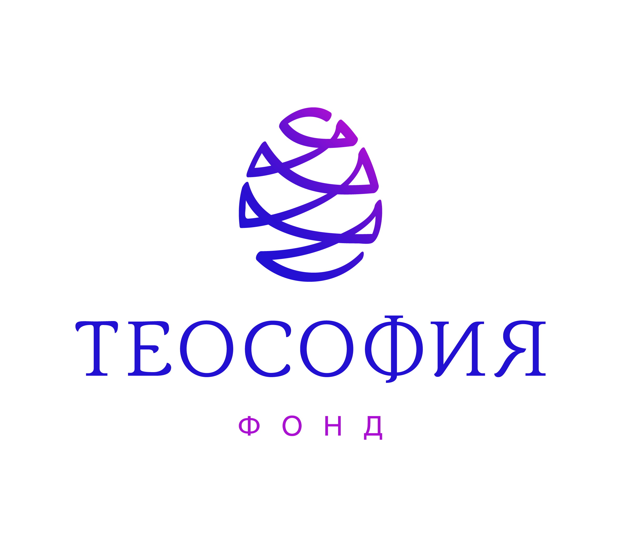

Color solution:
On the white background.
The cedar cone of purple and lilac colors (the purple color in the right part of the image blends with the lilac color).
Inscription: THEOSOPHY in purple letters.
Inscription: FUND – in lilac letters.

Option 2:
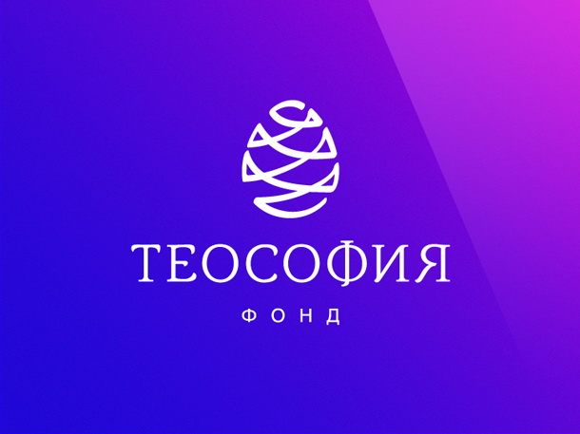

Color solution:
On the purple and lilac background.
The cedar cone in white.
Inscriptions in white.

1.13.2. Description of the Emblem.
The Emblem consists of both: graphics and texts.
The graphical part is represented as a spiral in a form of a cedar cone.
The textual part of the emblem. In the center of the emblem below the cedar cone there are two inscriptions: ''THEOSOPHY'' and ''FUND'', one below the other. The inscriptions are performed in capital letters (Barkentina font).
1.13.3. Meaning of the Emblem:
The cedar cone performed in a spiral form is associated with the great producing and creative Cosmic Power.
An image of the spiral in the form of a cedar cone is one of the most meaningful symbols of the Universe. An algorithm of the spiral is in the actual foundation of the creation itself.
1.14. Requirements of this Charter are legal and binding upon all bodies of the Fund, including its incinerator(s).
2. PURPOSES AND SUBJECT MATTER OF THE FUND
2.1. The Fund has been incorporated in order to generate assets based on voluntary proprietary contributions as well as on any other contributions not prohibited by the applicable law, and in order to use the said assets for development and support of Theosophy with the purpose of satisfaction of spiritual and other immaterial needs of the society.
2.2. In order to reach the aforementioned goals the Funds should solve the following problems, based on the main principles and ideas of theosophy:
2.2.1. promotion of theosophic knowledge among the public, popularization of theosophic ideas in the field of education, science, culture, arts, etc;
2.2.2. assistance in generation and promotion of the spiritual values based on the theosophic ideas and principles;
2.2.3. assistance in integration of efforts of those, who study or are interested in the theosophic science, integration of different methods and systems, promoting evolutionary development;
2.2.4. assistance in studying the Time Laws or Kalachacra (Sanskrit ''the Wheel of Time''), as a scientific basis for Theosophy, in promotion, translation and publishing of sacred Tibetan and Buddhistic texts, as well as ancient Indian philosophical works, including the ones, promoting development of exact sciences, viz.: Astrology, Astronomy, Physics, Chemistry, Biology, Psychology, and Medicine;
2.2.5. assistance in comparative study of religions, Philosophy, and science;
2.2.6. promotion of culture and arts full of spiritual and moral content, enlargement and strengthening of cultural connections based on traditions or Theosophy and popularization of the best heritage of the global culture.
2.3. Subject matter of the Fund is the aggregate of the following activities, aimed at reaching the goals and purposes of the Fund:
2.3.1. support and realization of programs, projects, and events, including conferences, lectures, seminars, meetings, trainings, workshops, discussions, round tables, briefings, etc, aimed at reaching of goals and purposes of the Fund, both on its own and collectively with other legal and natural persons;
2.3.2. charitable activities;
2.3.3. support and realization of programs, projects, and events related to exchange of experience in the field of theosophic activities; support of efficient cooperation between scientific, cultural, educational organization, and business communities for the purposes of experience sharing;
2.3.4. provision of financial, organizational and other support of any initiatives from people and organizations, in accordance with the purposes and goals of the Fund;
2.3.5. assistance in incorporation of new research, outreach and other centers, activities which aim at reaching the purposes and goals of the Fund;
2.3.6. support and conducting of culturally significant events, viz.: concerts, exhibitions, festivals, theater performances, and other social and cultural evens aimed at reaching the purposes and goals of the Fund;
2.3.7. support of lawmaking related to activities of the Fund; support of scientific research related to legislative proposals;
2.3.8. studying of public opinion related to the field of Theosophy;
2.3.9. dissemination of information related to activities of the Fund, including engaging of mass-media; organization and financing of publications, production (issuing) and demonstration of films, videos, media-presentations, and other forms of information dissemination using contemporary technologies as well as all kinds of dissemination of monographs, collections, text-books, study guides, reference books, etc, aimed at reaching the goals and purposes of the Fund;
2.3.10. publishing and polygraphic activities in accordance with the purposes and goals of the Fund;
2.3.11. organization of exhibitions, museums, libraries, resource centers and data bases for the purposes and goals of the Fund;
2.3.12. organization and use of social advertising for the purposes and goals of the Fund;
2.3.13. participation in grants competitions, other similar projects and programs in order for the Fund to receive financial support from the State, legal and natural persons, and, therefore, to be able to reach purposes and goals of the Fund;
2.3.14. cooperation with State and local authorities in respect of the activities of the Fund.
2.4. The Fund has not been founded with the purpose of profit-making, and, therefore, shall not pay off any income from received profits to the incorporator of the Fund or other persons. Any income, received as a result of any activities of the Fund, should be used in order to reach purposes and goals as specified hereinunder.
2.5. The Fund may perform profit-making activities only if it is required to reach goals and purposes specified hereinunder and in strict compliance with them. The said activities are: demonstration of movies, videos, media-presentations, as well as all kinds of dissemination of monographs, collections, text-books, study guides, reference books, etc, aimed at reaching the goals and purposes of the Fund; publishing and polygraphic activities in accordance with the purposes and goals of the Fund; concerts, exhibitions, festivals, theater performances, and other social and cultural events aimed at reaching the purposes and goals of the Fund.
In order to perform as aforementioned, the Fund shall own property with the market value not less than the minimal amount of the authorized capital specified by law in respect of any limited liability companies.
2.6. For the purposes and goals as specified hereinunder, the Fund may incorporate other non-commercial organization and join any associations (unions) subject to the Russian Federation legislation.
2.7. In order to create material conditions required for realization of the Charter goals and purposes, the Fund may incorporate business entities and (or) become a member of any business entities.
3. INCORPORATOR (INCORPORATORS) OF THE FUND
3.1. Incorporators of the Fund shall be fully capable sui juris natural and (or) legal persons, except for those, who can not incorporate non-commercial organizations subject to the applicable Russian Federation legislation. Foreign citizens or stateless persons, legally residing in the territory of the Russian Federation, may become incorporators of the Fund, except for the cases, specified by international treaties of the Russian Federation or by applicable Federal Laws. Any persons, specified by clause 1.2 Chapter 15 of Federal Law No. 7 as of January 12, 1996 ''On Non-Commercial Organizations'', shall not act as incorporators of the Fund.
3.2. The Fund Incorporator may:
3.2.1. participate in the activities of the Fund subject to the procedure as specified hereinunder, in particular, by means of becoming the Fund member;
3.2.2. be elected as an authorized person, having powers to act on behalf of the Fund without any Power of Attorney;
3.2.3. propose any matters for consideration by the administrative bodies of the Fund and related to the Fund activities;
3.2.4. receive information on the Fund activities and be granted access to the documents of the Fund, unless it violates any personal data rights or non-disclosure rights in respect of any other confidential information;
3.2.5. file a petition to a court of law on winding-up of the Fund;
3.2.6. make voluntary contributions and donations, including target ones, provide grants for performance of Charter activities, as well as make other proprietary and non-material support required for activities of the Fund.
3.3. An incorporator may resign from being the Fund incorporator at any time without prior coordination with the other incorporators of the Fund, by filing a corresponding notice, subject to the applicable legislation of the Russian Federation, to the Registering Authority. In case of resignation of the last or a sole incorporator of the Fund, such incorporator shall, prior serving of the aforementioned notice, transfer the incorporator's rights to some other person. The incorporator's rights may be transferred to another person, who is able to act as an incorporator of the Fund subject to the terms and provisions herein and subject to the applicable legislation of the Russian Federation, provided that person is interested in reaching the Charter purposes and goals. The rights may also be transferred to a member of the Council or President of the Fund. Transfer of the incorporator's rights shall be performed based on a corresponding resolution made by an incorporator or a sole incorporator of the Fund provided there is a written consent from the incorporator, accepting the said rights. Registration of a new person as an incorporator of the Fund shall be properly performed subject to the applicable legislation.
3.4. Rights and obligations of an incorporator of the Fund in case of resignation shall cease at the registration date of corresponding alterations in the State Unified Register of Legal Entities. A resigned incorporator shall correspondingly notify the Fund on the date of filing of a corresponding application to the Registering Authority.
3.5. The Fund incorporator(s) do not possess any proprietary rights in respect of the Fund, they are not liable for any obligations of the Fund, and neither the Fund is responsible to any obligations of its incorporator / incorporators.
3.6. The Fund incorporator(s) shall strictly comply with the terms and provisions herein and other internal documents of the Fund.
4. BODIES OF THE FUND
4.1. The Fund has the following bodies:
4.1.1. the supreme collegial governing body: Governing Council of the Fund (hereinafter – the Council);
4.1.2. sole executive body – President of the Fund (hereinafter – President);
4.1.3. a supervising body is the Supervisory Board of the Fund (hereinafter – the Supervisory Board).
4.2. The Fund may have other collegial bodies. Names, members, and competences of the said bodies shall be specified hereinunder.
4.3. The Fund shall not pay any remuneration to members of the Council and the Supervisory Board for performance of their actual duties, except for reimbursement of any expenses, incurred to them as a result of participation in activities of the Fund.
5. GOVERNING COUNCIL OF THE FUND
5.1. The Council is a supreme collegial body of the Fund, the main function of which is to secure compliance by the Fund with any purposes for which it has been founded.
5.2. Members of the Council should be fully capable sui juris natural persons.
5.3. Persons being members of the Council perform their duties on the free-of-charge basis.
5.4. Members of the Council shall not act as members of the Supervisory Board.
5.5. The Council shall consist of not less than 3 (Three) members.
5.6. Commissions of the Council members expire in 3 (three) years. Each person may be re-elected as a member of the Council for any number of times.
5.7. Appointment (election) of members into the Council and early termination of their commissions as well as approval of internal documents of the Fund, governing activities of the Council, shall constitute the sole competence of the Fund incorporator(s).
5.8. Commissions of the Council member may be early terminated:
5.8.1. upon a personal application from the Council member;
5.8.2. in case of death of any member of the Council, or in case of being properly acknowledged as a missing, diseased or incapable person;
5.8.3. in accordance with a corresponding resolution by the Fund incorporator(s).
5.9. Voluntary resignation of any member from the Council does not require prior consent from the Fund incorporator(s).
5.10. The Council is hereby authorized to handle the following matters:
5.10.1. developing the admission and dismissal procedures into and from the founding members of the Fund;
5.10.2. developing the most significant activity spheres of the Fund, principles of generation and utilization of its assets;
5.10.3. introduction of alterations into the Charter of the Fund;
5.10.4. foundation of other bodies of the Fund and early termination of their powers;
5.10.5. approval of annual reports and annual accounting (financial) documentation of the Fund;
5.10.6. making decisions on foundation by the Fund of any business entities and (or) on becoming their member.
5.10.7. making decisions on foundation by the Fund of any other legal entities, on joining any associations (unions), or on becoming their member;
5.10.8. making decision of foundation of any offices or representative office of the Fund;
5.10.9. approval of any transaction, executed by the Fund, in cases, specified by the governing law;
5.10.10. election of President and early termination of President's powers;
5.10.11. approval of an auditing company or a private auditor for the purpose of audit of the Fund;
5.10.12. management of the Fund's real estate;
5.10.13. approval of the Fund's symbolics;
5.10.14. approval of internal documents of the Fund, governing activities of the Council and President.
5.11. The Council may take for consideration any other matters, related to activities of the Fund;
5.12. All matters, specified by clauses 5.10.1 – 5.10.11, are within the sole competence of the Council. Any matters, not specified as within the sole competence of the Council, may be transferred by the Council for consideration to other bodies of the Fund.
5.13. The Council performs in a form of official meetings. Regular meetings shall be called as and when necessitated, but at least annually. Special meetings of the Council shall be convened upon a corresponding request from any incorporator(s) of the Fund, President, or upon requisition of at least half of the Council members or at least one third of the Supervisory Board members.
5.14. Official meetings may take place by conference-calls (videoconferencing), as well as by using other technical means of communication, allowing to confirm actual participation and declared intent of the Council member in real-time mode. The fact of participation of the Council members in a meeting using the aforementioned communication means shall be specified in the corresponding minutes.
5.15. The following persons have the right to attend meetings of the Council and execute the advisory capacity: the Fund incorporator(s), President, Chair of the Supervisory Board or one of the Supervisory Board members subject to a corresponding resolution of the Supervisory Board Chair. The said meetings may also be attended by other invited persons who may also be granted the advisory capacity.
5.16. The necessary quorum for proper performance at the Council meeting shall be more than half of the Council members.
5.17. Each member of the Council is entitled for one vote.
5.18. Resolutions of the Council related to the matters of its sole competence shall be passed by the majority of the qualified members, viz. not less than by two thirds of votes of members, present at the meeting.
5.19. Resolutions of the Council related to the matters that are not within its sole competence shall be passed by the simple majority of votes of members, present at the meeting.
5.20. Transfer by the Council member of his/her powers, (including the right of vote) to another Council member or to any other person by proxy is prohibited.
5.21. Everyday activities of the Council shall be organized by the Council Chair by:
- approving of an agenda and conducting the Council meetings;
- signing of the Council minutes and other documents, approved by the Council.
5.22. The Council Chair shall be elected by the Council members on the first meeting of the Council. Later on the Council Chair shall be elected by the Council members of their number at the last meeting of the Council preceding expiration of commissions of the Chair-in-Office. Effective period of the commissions of the Council Chair shall be 3 (Three) years.
5.23. In the event of a tie the Chair shall have a casting vote.
5.24. In case the Council Chair is not present at a meeting, a member of the Council, elected by the members of their number, shall act as the Chair of the meeting. In this case, the provision regarding the right to the casting vote is not applicable.
5.25. Resolutions of the Council shall be legal and binding on all bodies and officials of the Fund.
6. PRESIDENT OF THE FUND
6.1. The sole executive body of the Fund shall be President.
6.2. President performs day-to-day management of the Fund and is subordinate to the Governing Council and to the incorporator(s) of the Fund.
6.3. A person, holding the position of President, may also be a member of the Council. Although, the same person shall not hold the office of President and the Council Chair or the office of President together with membership in the Supervising Board.
6.4. Election of President shall be performed by the Council. President may be elected from among the Fund incorporators. The Council may early dismiss President in accordance with the procedure and provisions, specified herein and by the Russian Federation legislation.
6.5. The President shall be elected for the period of 3 (three) years. The same person may be re-elected for an unlimited number of times.
6.6. President of the Fund shall handle all matters, that are not within the competence of other bodies of the Fund. At that, President may issue a proxy transferring some of the President's powers to any third person(s).
6.7. President:
6.7.1. acts on behalf of the Fund without a Power of Attorney;
6.7.2. performs general management of the Fund activities;
6.7.3. represents the Fund at State authorities, local bodies, commercial and non-commercial organizations;
6.7.4. issued Powers of Attorney for acting on behalf of the Fund;
6.7.5. performs control over activities of the Fund employees, offices, and representative offices;
6.7.6. executes civil and legal transaction on behalf of the Fund;
6.7.7. manages assets of the Fund in accordance with the internal documentation of the Fund;
6.7.8. opens up in banks and other financial institutions operating and other accounts on behalf of the Fund, including primary signatory authority for billing and other financial documentation;
6.7.9. adopts rules, provisions, and other internal documents of the Fund, except for the documents, that should be approved by other bodies of the Fund subject to the terms and provisions herein;
6.7.10. approves staff schedules; executes and terminates labor contracts with the Fund employees on behalf of the Fund and in accordance with the applicable Russian Federation legislation;
6.7.11. secures execution of resolutions adopted by the Council;
6.7.12. prepares materials, projects and offers on the matters filed for consideration of the Council and the Supervising Board;
6.7.13. issues orders and gives instructions that are legal and binding on all employees of the Fund;
6.7.14. solves other matters related to activities of the Fund, except for those, that should be within the competence of other bodies of the Fund.
6.8. President shall comply with requirements of the applicable legislation, this Charter, resolutions of the Council and Supervisory Board, adopted within their competence.
7. SUPERVISORY BOARD OF THE FUND
7.1. The Supervisory Board is a collegial body of the Fund, performing supervision over activities of the Fund, adoption by the Council, President and other bodies and officials of the Fund of resolutions, securing execution of the said resolutions, use of the Fund assets, compliance by the Fund with the Russian Federation legislation.
7.2. Membership in the Supervisory Board may be acquired only by reputable and authoritative people who expressed their intent to support purposes and goals of the Fund as well as intent to participate in the activities of the Fund by making a personal contribution.
7.3. The Supervisory Board performs all activities pro bono.
7.4. The Supervisory Board has been established with the purpose of attraction of finances and other support required for Charter activities of the Fund.
7.5. The Supervisory Board shall consist of at least 3 (three) members.
7.6. Commissions of the Supervisory Board shall be valid for 3 (three) years.
7.7. Membership of the Supervisory Board may be granted upon acquiring a prior consent from an invited person.
7.8. The Fund does not acquire any rights and/or obligations through any actions of the Supervisory Board members.
7.9. List of members of the Supervisory Board shall be available and provided to any interested parties.
7.10. Quantitative and personnel structure of the Supervisory Board shall be determined based on corresponding resolutions of the Council. The first structure of the Supervisory Board shall be generated within three months as of the Fund state registration date.
7.11. A member of the Supervisory Board must not be an incorporator, a member of the Council, or President of the Fund.
7.12. Commissions of the Supervisory Board member may be early terminated:
7.12.1. upon a personal application from the Supervisory Board member;
7.12.2. in case of death of any member of the Supervisory Board, or in case of being properly acknowledged as a missing, diseased or incapable person;
7.12.3. in accordance with a corresponding resolution adopted by the Council.
7.13. The following matters shall be within the competence of the Supervisory Board:
7.13.1. supervision over activities of the Fund and compliance with the Charter purposes of the Fund;
7.13.2. supervision over compliance by the Fund with applicable requirements of the Russian Federation legislation, including proper execution of resolutions adopted by management bodies of the Fund;
7.13.3. supervision of utilization of the assets of the Fund;
7.13.4. other powers specified by the applicable legislation of the Russian Federation and this Charter.
7.14. The Supervisory Board while performing its supervising function shall make the following proposals for consideration by corresponding bodies of the Fund:
7.14.1. on areas of activities of the Fund, principles of generation and utilization of the Fund assets;
7.14.2. on audits regarding intended use of assets;
7.14.3. on performance of audits regarding financial and economic activities of the Fund;
7.14.4. on ways and forms of events aimed at attraction of funds with the purpose of performance by the Fund of the Charter activities;
7.14.5. on other matters related to operations of the Fund.
7.15. The Supervisory Board may acquire from the Fund any information and details regarding activities of the Fund, required for performance by the Supervisory Board of its obligations.
7.16. Decisions, recommendations, proposals, and claims of the Supervisory Board are mandatory for consideration by the Council and/or President as the case may be.
7.17. Meetings of the Supervisory Board shall be called as and when necessitated, but at least annually, and shall be convened upon a corresponding request of any incorporator(s) of the Fund, member of the Council or any member of the Supervisory Board.
7.18. The Supervisory Board shall at least annually provide recommendations on the following matters:
- on compliance of programs, projects and events of the Fund with the Charter goals and purposes;
- on intended use of the Fund assets.
7.19. Meetings of the Supervisory Board shall be performed in a form of a meeting in presentia (personal presence of the Supervisory Board members).
7.20. The following persons have the right to attend meetings of the Supervisory Board and execute the advisory capacity: the Fund incorporator(s), President, Chair of the Council or one of the Council members subject to a corresponding resolution of the Council Chair. The said meetings may also be attended by other invited persons that may also be granted the advisory capacity.
7.21. The necessary quorum for proper performance at the Supervisory Board meeting shall be more than half of the Supervisory Board members.
7.22. Resolutions of the Supervisory Board shall be passed by the simple majority of votes of members, present at the meeting. Each member of the Supervisory Board has one vote. Transfer by the Supervisory Board member of his/her powers, (including the right of vote) to another Supervisory Board member or to any other person by proxy is prohibited.
7.23. Everyday activities of the Supervisory Board shall be organized by the Supervisory Board Chair. The Supervisory Board Chair shall be elected by the Supervisory Board members on the first meeting of the Supervisory Board. Later on the Supervisory Board Chair shall be elected by the Supervisory Board members of their number at the last meeting of the Supervisory Board preceding expiration of commissions of the Chair-in-Office. Effective period of the commissions of the Supervisory Board Chair is 3 (Three) years. The Supervisory Board Chair prepares an agenda, conducts meetings, secures preparation and signs minutes of the meeting. In case the Supervisory Board Chair is not present at a meeting, a member of the Supervisory Board, elected by the members of their number, shall act as the Chair of the meeting.
8. ASSETS OF THE FUND AND SOURCES OF THEIR GENERATION
8.1. The Fund uses its own property for reaching the purposes and goals specified hereinunder, as well as for securing proper operation of the Fund, including salary for administrators and managers of the Fund.
8.2. The Fund may, subject to the applicable Russian Federation legislation, own or otherwise possess land parcels, buildings, structures, equipment, tools, transportation means, residential facilities, monetary amounts in Russian rubles and in foreign currency, securities, and other assets, required for financial support of the Charter activities of the Fund.
8.3. Assets generation sources for the Fund are the following:
8.3.1. one-time contributions from the Fund incorporator;
8.3.2. voluntary proprietary contributions and donations, including target ones, from Russian and foreign natural persons and legal entities in monetary form and in kind;
8.3.3. subsidies and grants;
8.3.4. dividends (income, interest) on shares, stock, bonds, and on other securities and deposits;
8.3.5. profits received from property of the Fund;
8.3.6. profits from operations of business entities incorporated by the Fund;
8.3.7. profits from any activities that may result in profit-making subject to the terms and provisions herein;
8.3.8. from other sources, not prohibited by the Russian Federation legislation.
8.4. The Fund may, in respect of its property owned or otherwise possessed by the Fund, perform any transactions that are not prohibited by the Russian Federation legislation, this Charter or some intended purpose of specific assets.
8.5. Any assets, transferred to the Fund by its incorporator(s) becomes own property of the Fund.
8.6. The Fund is responsible for its obligations with the assets, which, subject to the Russian Federation legislation, may be recollected.
8.7. The Fund shall publish corresponding reports regarding utilization of its assets on the annual basis.
9. OFFICES AND REPRESENTATIVE OFFICES OF THE FUND
9.1. The Fund may found offices and representative offices in the territory of the Russian Federation in accordance with the Russian Federation legislation.
9.2. Offices and representative offices of the Fund are legal entities, that shall have assets of the Fund and operate subject to the provisions, adopted by the Governing Council of the Fund. Property of an office or a representative office shall be accounted by its own accounting books and in the accounting balance of the Fund.
9.3. Heads of offices or representative offices of the Fund shall be appointed by the Fund and shall act based on a corresponding Power of Attorney issued by the Fund.
9.4. Offices and representative offices operate on behalf of the Fund. The Fund is responsible for all operations of its offices and representative offices.
9.5. The Council shall be responsible for decision-making on winding up of offices and representative offices of the Fund. Simultaneously with making the said winding-up decision it is required to allocate property and assets used for operations of a dissolved office or a representative office.
10. CHARTER ALTERATION PROCEDURES
10.1. The Charter may be amended by a corresponding resolution of the Council.
10.2. The Charter may be amended by a corresponding court decree adopted upon application of the Fund bodies or a State Authority, authorized to perform supervision over activities of the Fund, in cases, when keeping the Charter unaltered may result in consequences that could not be foreseen at incorporation of the Fund, but the Council fails to introduce required alterations into the Charter.
10.3. Any alterations introduced into the Charter shall be properly registered by the State Registrar and shall become legal and binding upon the said registration.
10.4. In case of one or several provisions of this Charter become invalid or unenforceable, this should not result in invalidation or unenforceability of the remaining provisions hereinunder.
11. RE-ORGANIZATION AND DISSOLUTION
11.1. Re-organization of the Fund is hereby prohibited.
11.2. The Fund may be dissolved based on a corresponding court decree taken as a result of a petition from interested parties, including member(s) of the Council, the Supervisory Board, President, or any incorporator of the Fund, provided:
11.2.1. the Fund has insufficient assets required for the goals and purposes as specified by the terms and provisions herein, and in case it is highly improbable to acquire such assets;
11.2.2. goals and purposes of the Fund can not be reached, and required amendments for the purposes of the Fund can not be introduced;
11.2.3. the Fund fails to comply with the goals as specified hereinunder;
11.2.4. in other cases, specified by the Russian Federation legislation.
11.3. In case a court decides to dissolve the Fund, the assets of the Fund remaining upon discharge of claims, shall not be transferred in favor of the Fund incorporator(s). Such assets shall be transferred for the purposes directly specified hereinunder.
11.4. Dissolution of the Fund shall become final, and the Fund ceases to exist upon making corresponding registration records into the RF Unified State Register of Legal Entities.

